

BAŞKENT UNIVERSITY
ELECTRIC & ELECTRONICS ENGINEERING

EEM 214 ~ ELECTRONICS–I
LABORATORY
PRELIMINARY

Experiment Name : Diode Clipping & Clamping Circuits
Experiment Number : 5

Student Name : Buğra BAYRAM
Student Number :20193272
Experiment Date/Day: 7 / 4 / 2006
Laboratory Number:

Honor Pledge:

I did this preliminary work or lab report by myself and I have neither cheat from anybody nor let anybody cheat from me at the any part of this work.

Student Signature:
……………………….

2-)
a-)

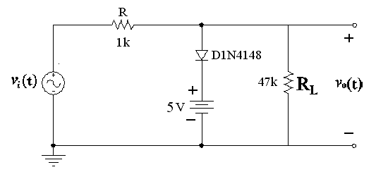

Our input voltage is Vin=10 Vpeak , diode will be on when input equals Vdc+Vdiode=5+0,7=5,7 V.So output voltage is equal to input voltage when input is between 0 V and 5.7V range,after 5,7 V diode would be on,this means current stops flowing across RL,starts flowing across the diode so the output voltage would be constant 5,7V.When input is between 0V and -10V range,diode is off,so Vin = Vout in this region.
Finally we can say,we clipped output voltage at 5,7 V

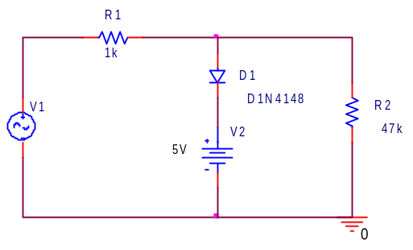
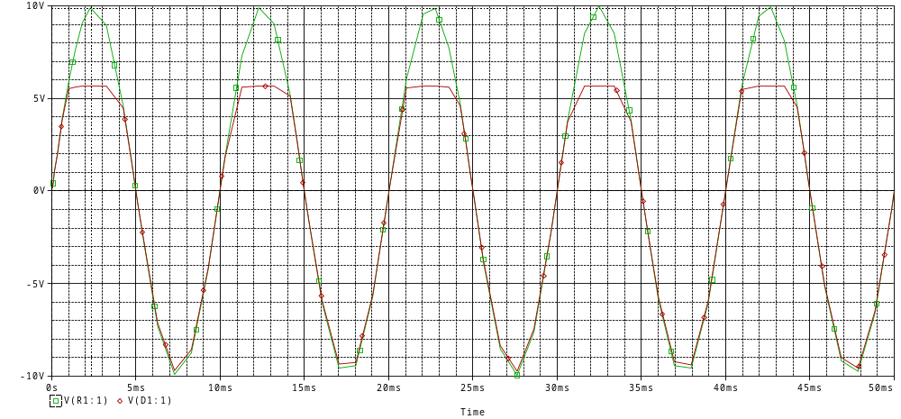20193272
b-) When we reverse the diode and the 5V DC source,while input is between 0V and 10V range,diode is off so the output voltage is equal to input voltage.When input is between 0V and -10V range,diode is on after –5-0,7=-5,7 V so after this value current will be flow across the diode,it means output is constant –5,7 V value.

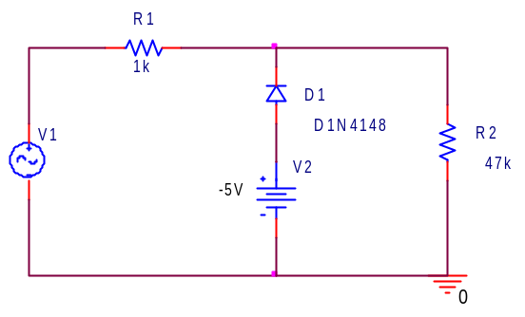
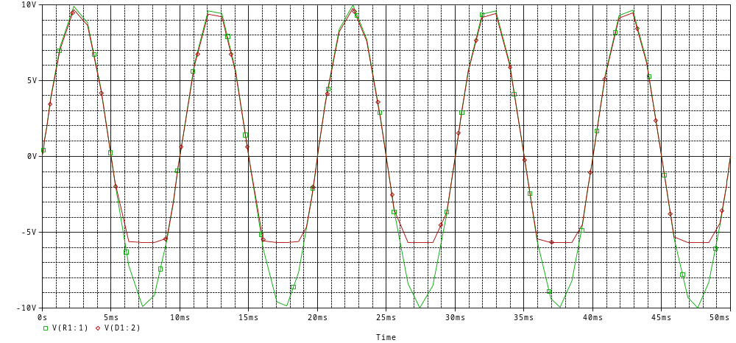
20193272

3-)
a-)
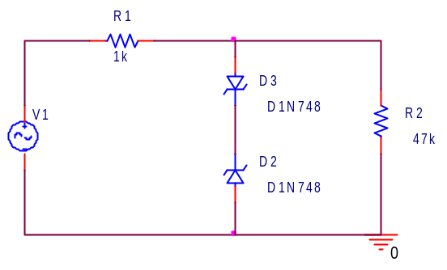
When Vin is between 0V and 10V range,the upper zener is acts as a diode,the lower is acts as a DC source ( Vz = 3,9 V ),after Vz + 0,7 V=4,6V upper zener diode is on so the output is clipped to 4,6V.
When Vin is between 0V and -10V range,the upper zener is acts as a DC source ( Vz = -3,9 V ),the lower is acts as a diode,after –3,9V-0,7V=-4,6V,upper zener is on so the output is clipped to the –4,6V value.
Finally output is clipped between –4,6V and +4,6V.

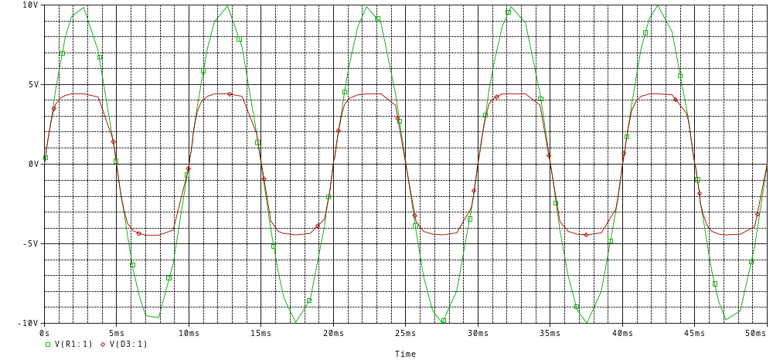
20193272

Vin,Vout and Vzener’s
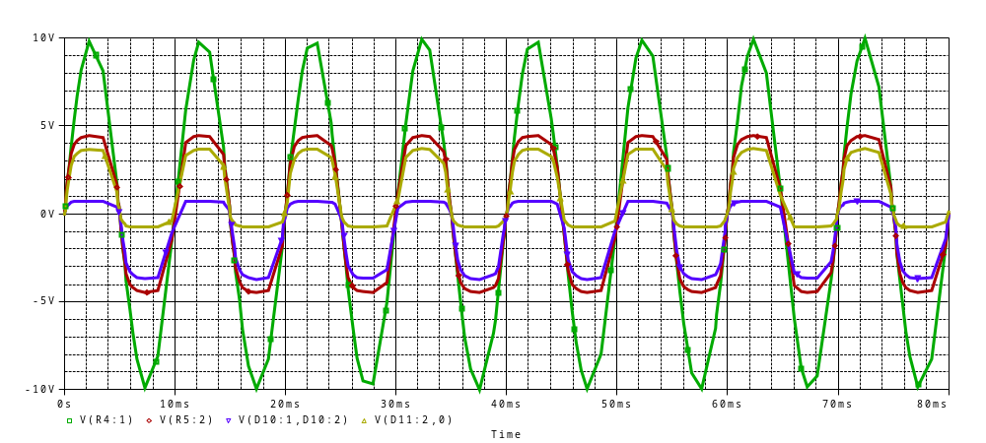
20193272

b-) When we reversed zener diodes,output voltage didn’t change.Only difference is upper
and lower diodes’ places.

4-)
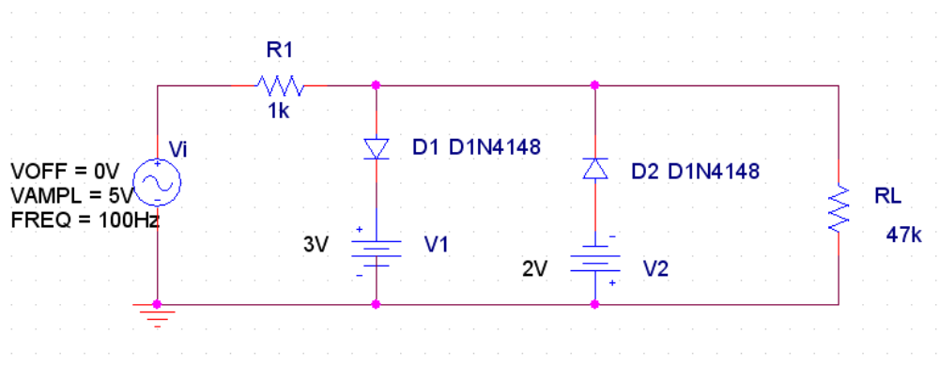
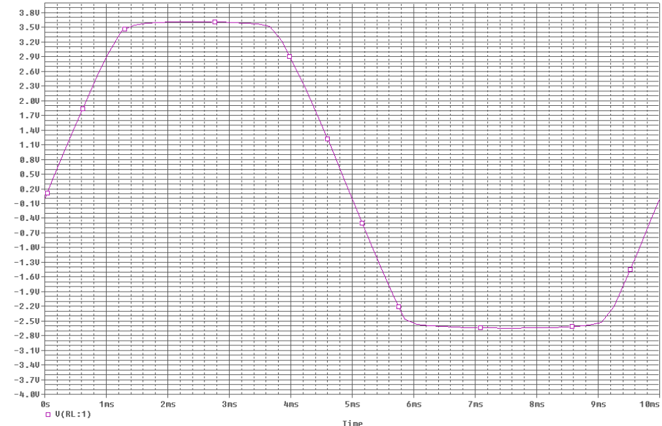
20193272
5-)
a-)

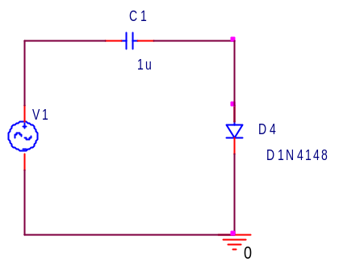
∫_{T} ( -10 + v_{i}(t) + V_{diode}) dt = -10 + V_{diode}
The output voltage is between -Vp + V_{diode} = -10 + 0.7 = -9.3 V and 0V

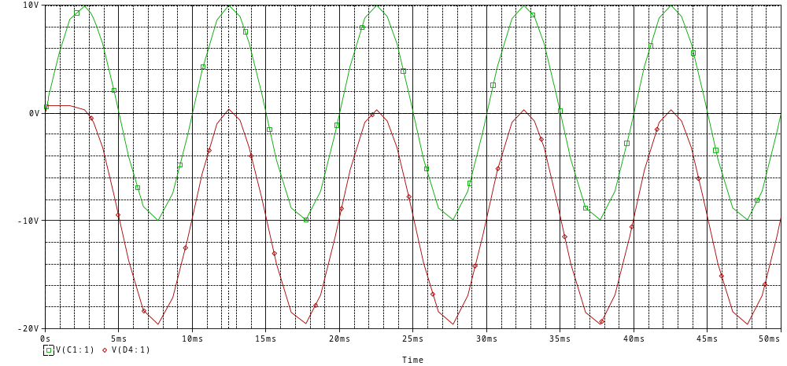
20193272

DC(average)

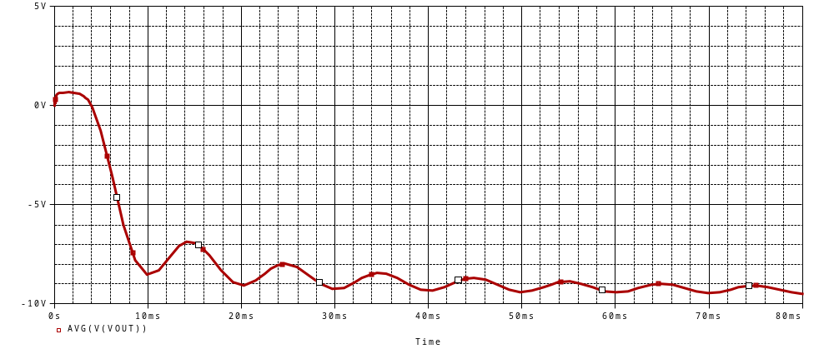
20193272

b-)
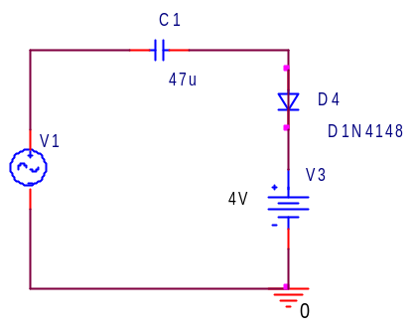

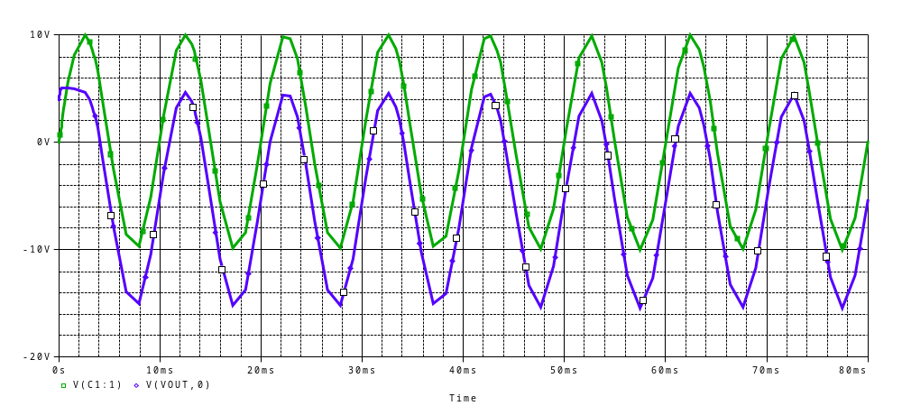
20193272

DC(average)
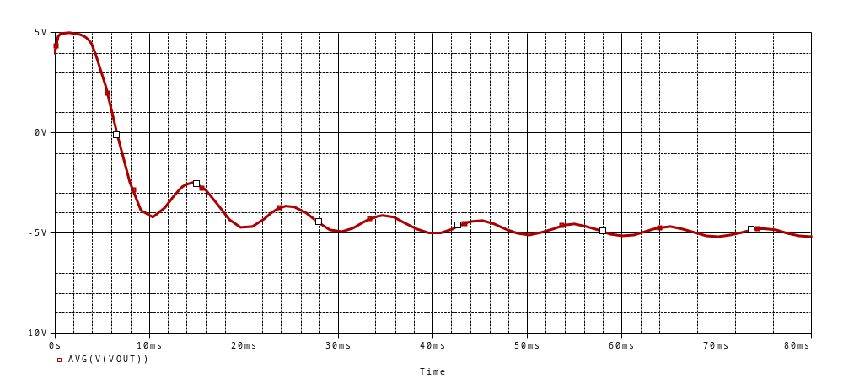
20193272

c-)
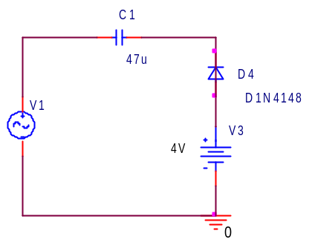

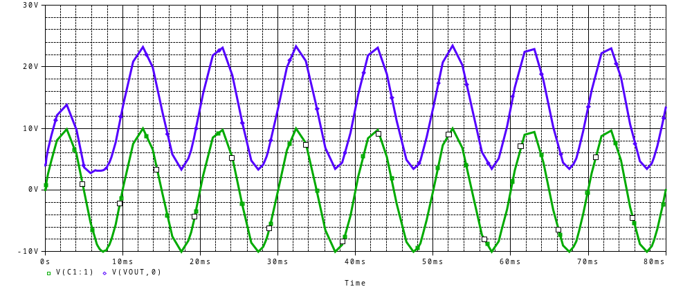
20193272

DC(average)

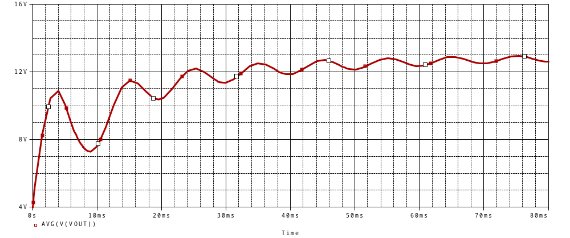
20193272

6-)
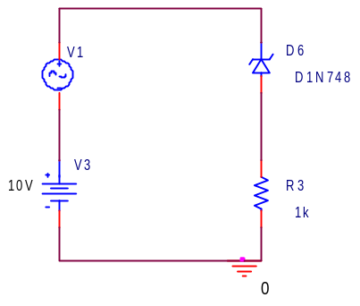

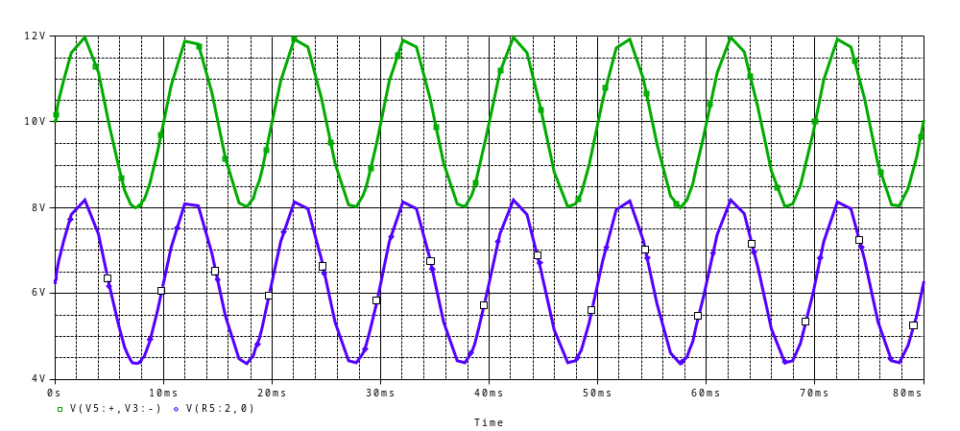
20193272

